Interactive Visual Chain-of-Thought: Designing Collaborative Reasoning Workspaces for Human-AI Sensemaking

Nathan Conklin
nathan.conklin@vt.edu
Department of Computer Science,
Virginia Tech
Chris North
north@cs.vt.edu
Department of Computer Science,
Virginia Tech

1. Introduction and Motivation
Users interact with large language models (LLMs) through conversation. The user issues a prompt, the model returns an answer, and the user re-prompts to refine the result. This loop works for many tasks; it also hides the most valuable part of the exchange, the model's reasoning. Modern reasoning models produce long intermediate deliberations before they answer, including chain of thought, tool invocations, and exploratory branches. The user sees almost none of it. The user cannot inspect the reasoning, correct a flawed premise mid-stream, or apply domain judgment at the point where it would change the outcome. A legible chain of thought would let the user review the model's work, and that review could improve both the continuation of the dialogue and the final answer.
This research designs, prototypes, and evaluates collaborative reasoning workspaces: interactive visualization environments that externalize an AI system's reasoning as a structured, navigable, and editable artifact. Raw chain of thought is the wrong display target. Raw traces are information dense and traverse through abandoned rabbit holes. Frontier labs, including OpenAI and Anthropic, also withhold them; verbose traces support distillation attacks in which a competitor recovers information about training data and model behavior. The workspace concept avoids both problems. It offers a shared work table built from hypotheses, evidence, assumptions, and decisions, and both the human and the AI can read, question, and modify it. This framing places the contribution in human-AI collaboration rather than model tracing, and it follows the Space to Think tradition in visual analytics: give the analyst an externalized spatial workspace where sensemaking can unfold.
One asymmetry motivates the design work. A reasoning model weighs many alternatives at each step but commits to a single path; it never traverses the alternatives. A naive rendering of the trace therefore looks the same each time: a tall tree whose untaken branches all terminate at depth one, which tells the user nothing. The design problem is to depict decisions and alternatives in a way that carries meaning. The interface should show where the model chose, why it chose, how confident it was, and where human judgment could change the outcome.

2. Problem Statement
Three problems define the research space.
Machine reasoning is opaque in conversational interfaces. Current chatbots deliver conclusions without reasoning. Even when a thinking trace is available, the interface presents it as undifferentiated prose that users cannot parse, verify, or act upon. The interface positions the human as a consumer of answers instead of a collaborator in reasoning.
Reasoning traces have density without structure. Traces from tool-using models are long and heterogeneous; they mix goals, sub-goals, retrieved evidence, assumptions, dead ends, and conclusions. Exposing more of the trace without an organizing representation makes the problem worse. The representation itself, and the rendering built on it, are both design objects.
Uncertainty is invisible. A model's confidence varies across the components of a single response. Some claims rest on strong evidence; others rest on thin assumptions. Interfaces today show nothing, or at best a single global score, so users cannot direct scrutiny toward the parts of a response that need it.

3. Research Questions
- RQ1 (representation): What structured representation of machine reasoning, in terms of node and relationship vocabulary, best supports human comprehension, verification, and intervention, given that raw chain of thought is unavailable in full and unsuitable as a display target?
- RQ2 (uncertainty): Does exposing reasoning certainty at the level of individual reasoning components improve human decision-making and trust calibration, compared with a single overall confidence score or none? I hypothesize that it does.
- RQ3 (interaction): Which interaction techniques convert a static explanation into an instrument of collaborative decision-making? Candidates include editing assumptions, simulating alternatives, filtering by confidence, and organizing reasoning artifacts in space.
- RQ4 (integration): How can proactive, agentic AI assistance embed into a user's ordinary working environment so that proposals stay separate from execution and the human retains orchestration control without distraction?

4. Proposed Approach

4.1 The Structured Reasoning Graph
A foundational artifact of this research is the structured reasoning graph: a machine-generated, JSON-serialized representation of a reasoning episode. Two generation paths exist. The primary reasoning model can emit its reasoning in structured form on request, or a second reasoning-architect model can reconstruct the structure from the prompt, the response, and the available trace. In either path, the graph is a designed abstraction over the raw trace, and its vocabulary is a research product.
The node vocabulary consists of goals, hypotheses, evidence, assumptions, constraints, uncertainties, decisions, and recommendations. Typed edges express relationships such as supports, contradicts, and depends on. A representative schema:
json
{
"nodes": [
{"id": "g1", "type": "goal", "text": "...", "certainty": null},
{"id": "h1", "type": "hypothesis", "text": "...", "certainty": 0.72},
{"id": "e1", "type": "evidence", "text": "...", "credibility": 0.9},
{"id": "a1", "type": "assumption", "text": "...", "certainty": 0.55},
{"id": "d1", "type": "decision", "text": "...", "alternatives": ["d1-alt1", "d1-alt2"], "rationale": "..."}
],
"edges": [
{"from": "e1", "to": "h1", "relation": "supports"},
{"from": "h1", "to": "d1", "relation": "informs"},
{"from": "d1", "to": "a1", "relation": "depends_on"}
]
}

The interface renders the graph as a node-link diagram, with one departure from naive trace visualization: layout and visual emphasis privilege decision points over exhaustive branch structure. Drawing all branches produces the uniform tall tree described in Section 1. The design collapses alternatives by default, expands them on demand, and attaches to each decision node a rationale for why the chosen path won. The result is a decision graph, and the research framing follows: this work designs tools for collaborative decision-making, with visualization of computation as a means.
Two signals emphasize decision points. First, the interface highlights nodes where human input changed the outcome, which makes the human's imprint on the reasoning visible and persistent. Second, the interface flags nodes where the model reports low confidence and can offer a second-opinion request at that node. The visualization becomes a map that reads "your judgment matters most here" and directs the user's attention accordingly.

4.2 Localized Reasoning Certainty
The second pillar is the visualization of reasoning certainty. I use the term reasoning certainty in place of confidence; the value is an estimate, not ground truth. The interface encodes certainty at the granularity of individual reasoning components and response sections, in place of a single global score.
Proposed encodings: a thin certainty bar beside each section of a textual response, drawn on a sequential grayscale or blue-saturation ramp because a red-green scale fails for users with red-green color-vision deficiency; background shading behind response text that separates stronger passages from weaker ones; and, within the reasoning graph, node color saturation for certainty, border thickness for the weight of supporting evidence, and small uncertainty glyphs on contested nodes. The dialogue evolves, so certainty is dynamic; encodings animate as new evidence arrives. This yields dynamic confidence tracking, a candidate research contribution on its own.
One design principle governs the encoding palette. Three quantities must remain separable in the visual design: model confidence (the model's self-report), reasoning certainty (estimated soundness of a reasoning step), and evidence quality (credibility of the underlying sources). An encoding that conflates them would mislead the same attention the interface tries to guide. The governing hypothesis for RQ2 is that localized certainty display, relative to a global score, improves how users allocate scrutiny and improves downstream decision quality. The long-term claim is broader: interfaces that make uncertainty legible move human-AI collaboration from a question-answer box toward a shared thinking space.

4.3 Feasibility and Initial Technical Slice
A small prototype will be developed to help establish the pipeline. The backend will use GLM 5.2, an open-source, open-weights reasoning model. Its reasoning performance is competitive with the frontier tier, at about the level of Claude Opus 4.8 or GPT-5.4, and unlike the closed APIs it exposes its full chain of thought. The frontend will use an existing open-source chat client, kept swappable and modified in increments.
The plan has three stages. Stage one exposes the raw chain of thought; end users will not consume it in this form, but the stage establishes data access. Stage two adds post-hoc visualization. After each response, a follow-up prompt, possibly to an alternative model, generates a visualization that depicts the response and the reasoning behind it. A strong image-generation model, such as OpenAI's, can take the user prompt, the model response, and the full chain of thought as context and render the thought process. Stage three replaces free-form depiction with the structured reasoning graph of Section 4.1, rendered in the interface itself. The plan requires no model training; prompting and post-processing supply all structure, which keeps the research focused on representation and interaction design.

5. Prototype Design Space
The design space is organized into four prototypes that form an evolutionary roadmap: from basic AI answers, to explained reasoning, to shared workspaces, to cognitive partnership. Each prototype anchors a candidate research focus and an experimental study. All four share one visual language: dark theme, subtle blue accents, clean HCI-research aesthetic, publication-quality rendering.

5.1 Prototype A: Enhanced Chat with Reasoning Panel
Interface description. Prototype A augments the familiar chat paradigm. A top bar displays the conversation title, the model version, and a "Structured Reasoning Graph" label; three regions sit beneath it. The left panel holds the conversation. Responses carry bold section headers and clickable references, and each section carries a thin vertical reasoning-certainty bar along its edge, encoded on a blue gradient. The upper-right panel hosts the interactive reasoning graph for the current exchange: goals, hypotheses, evidence, assumptions, and decisions as typed nodes joined by curved links. The lower-right panel presents evidence cards, each with a credibility indicator. The design reads as an HCI research prototype, distinct from a commercial chatbot.
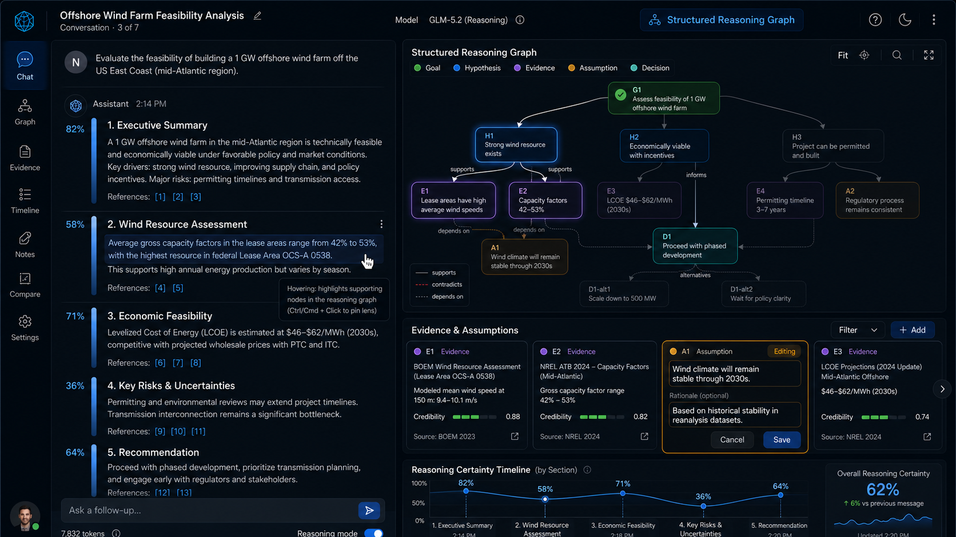
Figure 1: Enhanced chat-with reasoning graph, evidence map, and certainty visualization
Interactions. Prototype A synchronizes four coordinated views: natural-language response, reasoning graph, evidence map, and certainty visualization. Hovering over a passage of the response highlights the graph nodes that produced it, and hovering over a node highlights the passage. Reasoning details expand in place. Assumption cards are editable, so the user can revise a premise and observe the downstream effects. A timeline records confidence shifts across the conversation. The signature technique is the reasoning lens: the user clicks and holds any statement in the response, and the interface spotlights the supporting nodes and evidence, a magnifying glass for reasoning. These interactions move the interface from a chat log toward a collaborative reasoning environment.

5.2 Prototype B: Decision Workspace
Interface description. Prototype B inverts the visual hierarchy and makes the graph the primary object. A central decision graph of hexagonal nodes displays key decisions, their alternatives, underlying assumptions, and projected impacts. The right panel provides decision detail: a reasoning-certainty bar, supporting evidence, and conflicting alternatives surfaced by name. The conversation survives as a compact panel on the left. A bottom timeline shows how the decision graph evolved over the session. The visual style utilizes professional visual analytics; the layout is spacious, emphasizes depth and clarity without clutter, and treats decisions as the primary objects of interaction.
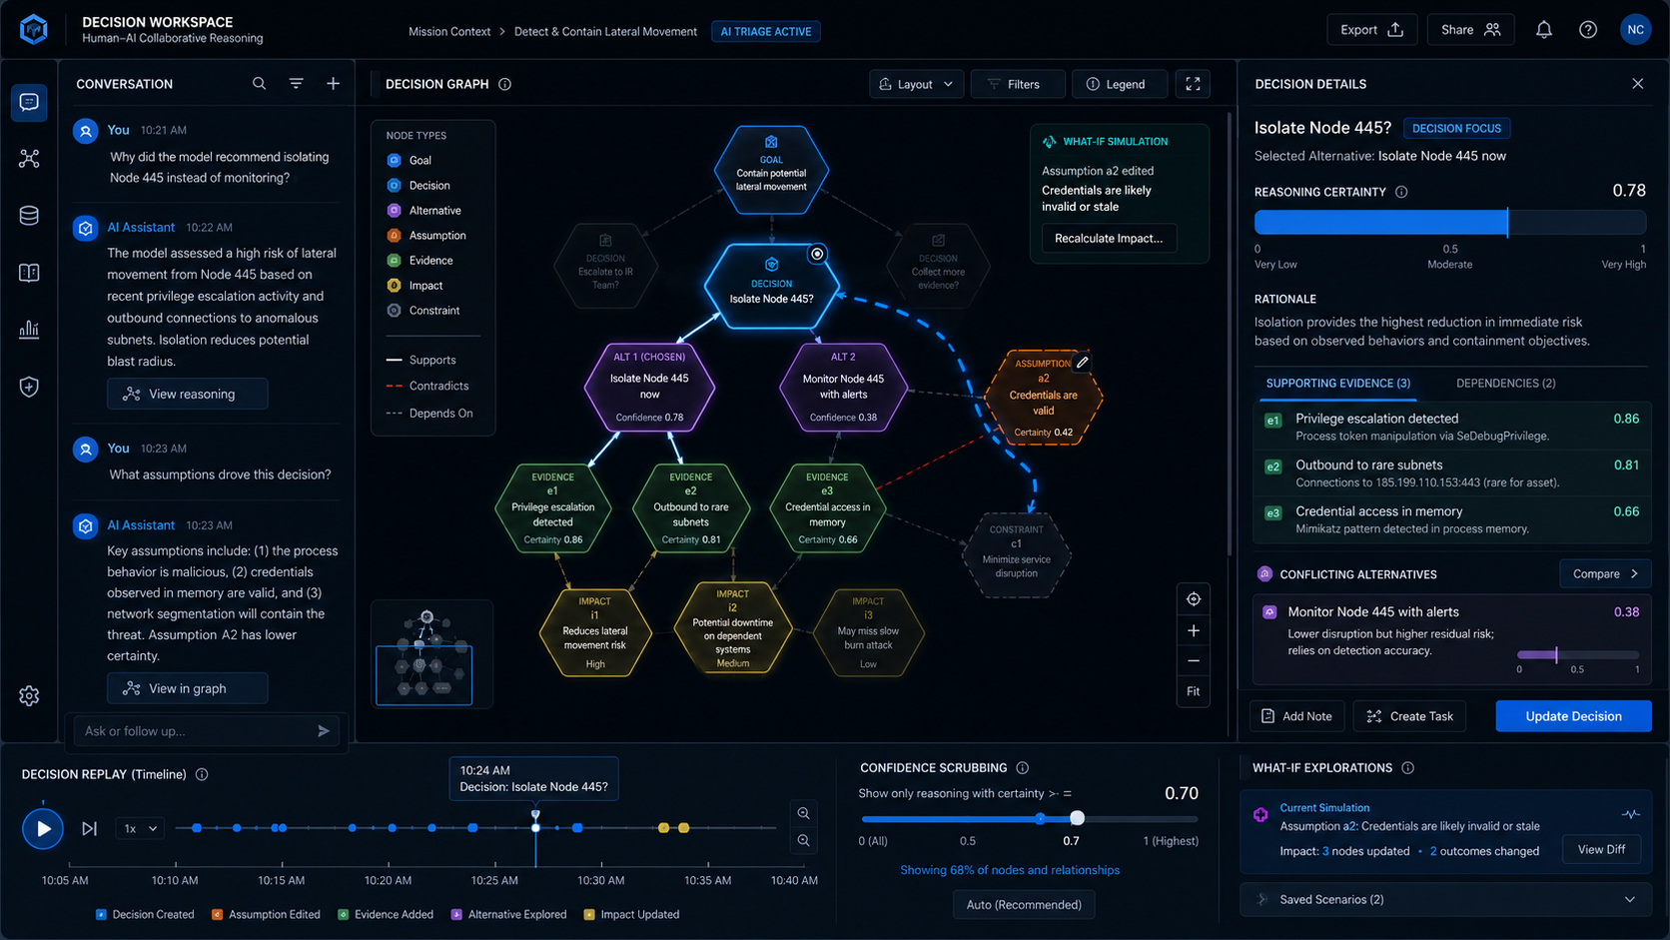
Figure 2: Decision Workspace to evaluation key decisions, alternatives, underlying assumptions, and uncertainties.
Interactions. Five techniques define the workspace. (1) Decision focus: the user clicks a node, the rest of the graph fades, and the evidence chain behind that decision lights up. (2) Alternative comparison: the user examines competing options side by side. (3) What-if simulation: the user tweaks an assumption and watches the graph animate the update as consequences propagate through dependent decisions. (4) Decision replay: a scrubber moves through the reasoning history and replays how the graph grew. (5) Confidence scrubbing, a novel interaction dimension: the user drags a slider to show only high-certainty reasoning, then widens it to admit ambiguity, which puts the amount of visible uncertainty under user control.

5.3 Prototype C: Collaborative Sensemaking Canvas
Interface description. Prototype C transitions from a chatbot towards a Sage-like shared cognitive workspace: an infinite, zoomable canvas that holds conversation cards, reasoning graphs, documents, and images in spatial clusters. The AI participates as an organizer; it connects ideas, suggests links, and proposes clusters. A context panel accompanies the canvas and shows reasoning certainty, evidence, and linked conversations for whatever holds focus. The visual language is simple and information-rich: smooth animations when ideas reorganize, subtle visual cues where evidence conflicts. The user navigates in space through zoom and pan, with the sense of stepping inside a living map of thought.
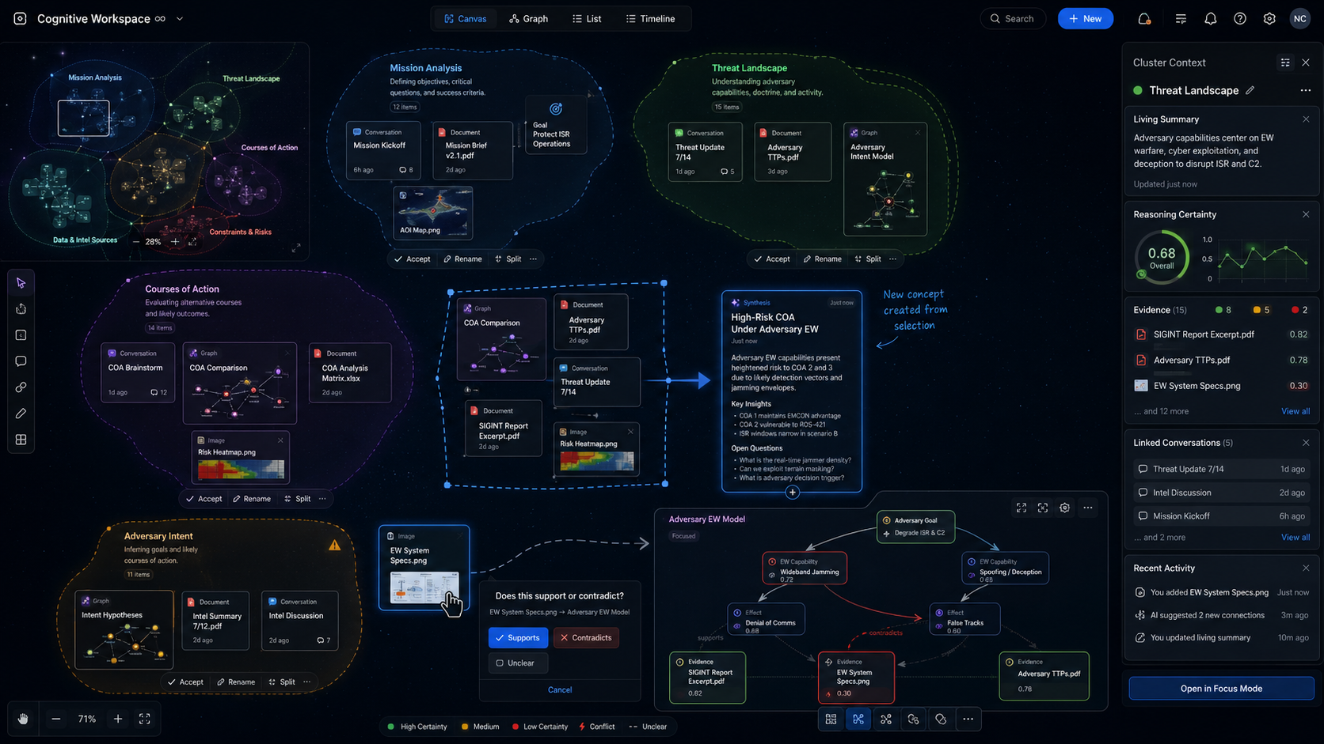
Figure 3: Collaborative Sensemaking Canvas enables spatial organization, clustering, concept synthesis, semantic linking, and living summaries.
Interactions. Six techniques form the heart of Prototype C. (1) Spatial organization: the user drags objects, and the AI infers meaning from proximity; position carries semantics. (2) AI clustering: the system suggests groupings and never forces reorganization; the user may accept, rename, or split any proposed cluster. (3) Concept synthesis: the user lassos several objects and asks the AI to synthesize; a new card appears with summary insights and open questions distilled from the selection. (4) Semantic linking: the user drags one object onto another, and the interface asks a relationship question, "Does this support or contradict?", so links are typed and made on purpose. (5) Living summaries: each cluster maintains a summary that the AI updates as evidence arrives. (6) Multiple levels of detail: zooming out reveals themes; zooming in reveals full reasoning graphs and conversations. The canvas becomes a spatial notebook of the investigation itself, in addition to a record of its results.

5.4 Prototype D: Cognitive Copilot (Ambient Agentic Partner)
Interface description. The final prototype utilizes AI as an attentive partner embedded in the user's ordinary working environment (a Windows desktop). In its purest form the interface shows no chat bubbles by default; AI insights appear in context beside the artifacts the user is viewing. A right panel maintains a reasoning-certainty display and a living evidence map, and the user can toggle between a conventional chat mode and the co-pilot mode. The extended vision places an operator in front of a familiar GUI desktop, a Windows-like workspace, with an agent running in the background, in the spirit of Claude Cowork. As the user works, small proposal cards surface around the screen and describe work the agent could take on ("I can add a chapter about this"; "I can compile this code"), each with a one-click approval button. On approval, that region of the workspace becomes agentic; the AI works on it and reports milestones while the human continues to orchestrate the rest of the desktop.
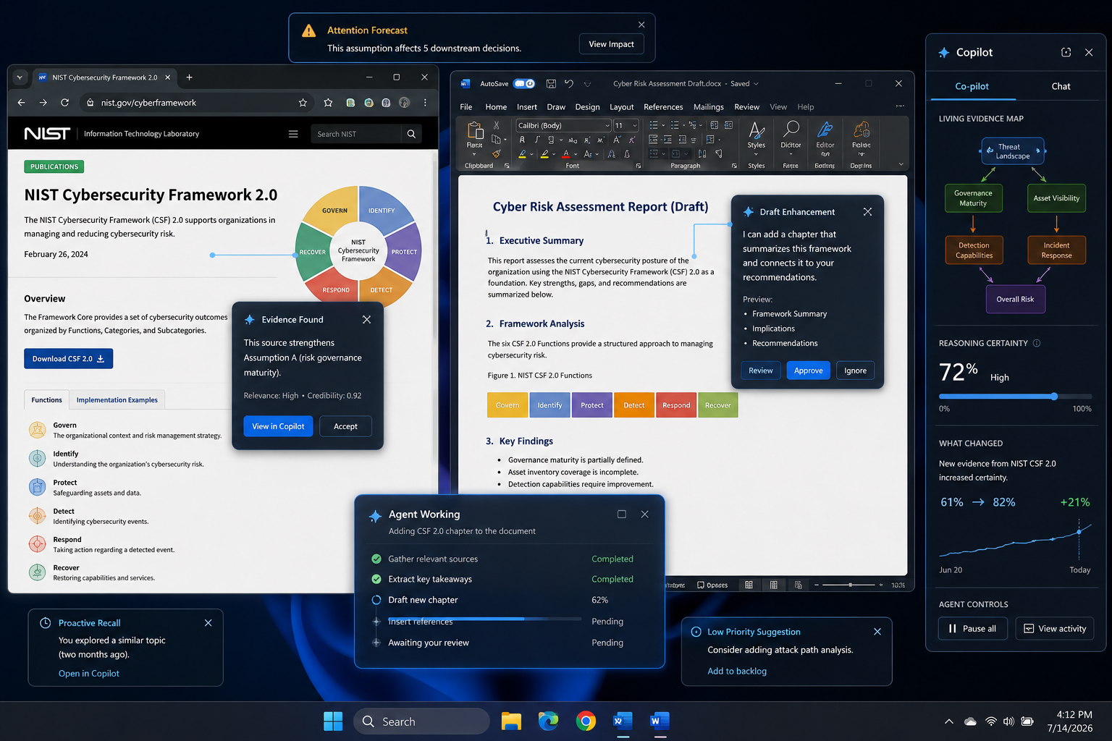
Figure 4: Cognitive Copilot provides an agentic partner that can suggest agentic actions and execute work on demand from within the user’s work environment.
Interactions. The user should feel co-piloted, never driven. Attention forecasting nudges the user toward consequential elements ("this assumption affects five downstream decisions"). Context-aware suggestions and just-in-time explanations answer "why did this change?" at the moment the user asks. Proactive recall resurfaces relevant prior work ("you explored something similar two months ago"). A what-changed view shows how new evidence altered reasoning certainty across the workspace. Proposal cards carry review and ignore affordances; approved tasks execute in the background with milestone reports that never hijack the user's flow. Attention orchestration surfaces low-priority ideas at the margins and urgent ones in prominence. The central research challenge, and the capstone contribution, is the clean separation of proposal from execution, so autonomous assistance integrates into a working digital workspace without disorienting the human in command. The workspace adapts over time, and it adapts gently; the user stays in control, partnered with the AI.

6. Research Roadmap and Expected Contributions
The four prototypes map into a research arc. The studies would evaluate, in order: comprehension and trust calibration with coordinated reasoning views (Prototype A); decision quality under what-if simulation and confidence scrubbing (Prototype B); sensemaking performance and externalization behavior on the spatial canvas (Prototype C); and interruption cost, oversight quality, and orchestration workload under ambient agentic assistance (Prototype D). Across the arc, the research tells a development story from explained reasoning to cognitive partnership, and each interface earns its place in that story.
Expected contributions: (1) a designed vocabulary and JSON schema for structured reasoning graphs, suited to post-hoc generation from open-weights reasoning models; (2) a framework and encoding palette for localized reasoning certainty, with empirical evidence on component-level versus global confidence display; (3) a catalog of interaction techniques for collaborative reasoning, including the reasoning lens, confidence scrubbing, what-if simulation, concept synthesis, and semantic linking; and (4) design principles for separating proposal from execution in ambient agentic workspaces.

